Village Tavern: Doing it All Wrong
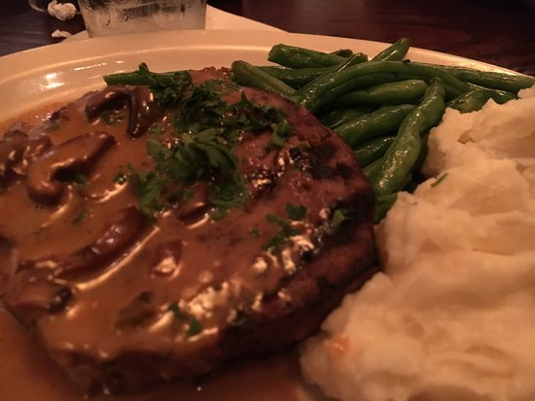
BY: CHRISTINA BENEDICT
November 2, 2016

I thought dinner at the Village Tavern was going to be a nice break from the college cafeteria food I had been eating for a month straight. A half mile walk from campus along the scenic Reynolda Trail, Village Tavern is a favorite among Wake Forest students. You cannot ask for a few restaurant recommendations on Wake Forest’s campus without hearing Village Tavern in every response. Maybe the restaurant is so popular due to its proximity. Maybe eating in a mess hall for weeks at a time lowers a person’s standard for decent dining. Or maybe the restaurant gains some of its status due to its carefree, casual atmosphere. Having been to Village Tavern a few times before, I would say the service is generally subpar, but one experience in particular was enough to turn me away from Village Tavern completely.

It was bad. From the get-go. Starting with the doors. As guests arrive, they are greeted by two unmarked doors on the backside of the restaurant – one leads to the lobby, the other is a service entrance. It’s a real-life spin on “What’s Behind Door #1?” often played on gameshows. Thankfully, my guest and I chose the correct entrance. We had barely made it through the door and the half-empty restaurant had already forgotten about us. I’m not sure if it’s because the staff holds a bias against young-looking college students, but the service we received was deplorable compared to the older customers situated at the tables around us. When a hostess finally approached us, they walked us (past several empty tables) to a small, uncomfortable corner behind the bar. We were tucked away in the corner of the restaurant as if we were being punished or shamed. To my left, two waiters were periodically snacking on appetizers, which they would leave open and unattended for minutes at a time while they served. In front of me was a large window overlooking a somewhat busy street and a dead tree. And to my right sat my guest, sitting completely sideways in the chair to combat the unnatural side by side placement. Strike one.

About fifteen minutes later – yes, fifteen – a waitress noticed us sitting in the back and asked to take our drink order. We both ordered water. How the phrase “two waters please” translated into “one water and one lemonade” I will never know, but that is what the waitress brought back. She then proceeded to take our food order sans-notepad before running back to the bar to finish her conversation with the bartender. It is probably not a surprise that the waitress had to come back and take our order again. At this point, my guest and I had been seated for nearly half an hour with zero chance of receiving any food in the foreseeable future.

It seemed as though the restaurant staff made the older customers a priority. All around us, the middle-aged guests were frequently visited by servers asking if they needed anything. In fact, a couple behind me was already enjoying their appetizers despite the fact that they had only been seated for fifteen minutes. Maybe the servers were not paying attention to us because they felt that two college students would leave them a small tip…in that case, it was a self-fulfilling prophecy.

My stomach panged of hunger. It was incredibly uncomfortable, making it nearly unbearable to remain at the restaurant. If Village Tavern takes anything away from this review, I hope it’s that they should offer customers a bread basket – especially since the staff is in no hurry to serve the actual meal.

“I am so sorry; I keep forgetting the second part of your order.” Yes, our waitress came back a second time to re-re-take our order. It gets worse. A few minutes later the waitress returned to let us know that the kitchen was out of shrimp and the Cubano sliders. Apparently, the kitchen staff at Village Tavern does not communicate with the servers very often, because in the 45 minutes that the waitress knew our order, no one told her they were out of shrimp and sliders. Strike two.

My guest and I re-re-re-ordered about the time that our crab dip appetizer was delivered. I will give credit where credit is due, the crab dip was everything a good crab dip should be, and more. Still warm from the oven, the light and silky texture of the dip was a pleasant complement to the toasted garlic bread dipper. Melted parmesan boosted the already flavorful dip, and hints of lemon added a subtle tanginess to the crab. The crab dip was a perfect, easy to indulge appetizer that almost made me forgive my waitress’s unapologetic attitude toward her multiple faux pas.

When the dinner finally arrived, I was expecting something on the same level as the crab dip. It wasn’t. The string beans were bland, cold, and limp. The meatloaf, although semi-cold, could have been good. But it was topped with a Madeira sauce whose bold caramelly flavor did not allow any of the smoky undertones to make the sauce savory enough to pleasantly compliment the meat. And the Ahi Tuna Sashimi was not as pure and refreshing as it would have been had the Tuna been more fresh. Strike three.

Needless to say, I was not impressed with the service or the preparation of the food at Village Tavern. The students at Wake Forest might need to expand their list of dining recommendations because the Village Tavern definitely struck out.

Want to give feedback? You can reach Christina at benecn14@wfu.edu.

Village Tavern: Scratch Kitchen, Craft Bar
Hours of Operation:
Monday - Thursday 11:00 AM - 11:00 PM
Friday - Saturday 11:00 AM - 12:00 Midnight
Sunday 10:00 AM - 10:00 PM

221 Reynolda Village
Winston-Salem, NC 27106
P: 336-748-0221

